2026-2027 Academic Year
Bon Secours Mercy Health- St. Francis Family Medicine
Blackstone Rural Track

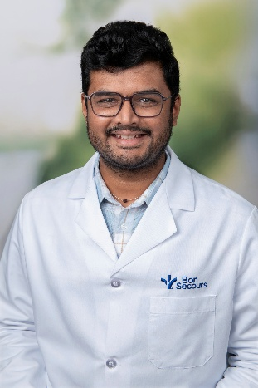 | Anand Anghan, MD  PGY 1  Medical School: Gov’t Medical College Surat  Personal interests: I enjoy playing cricket and pickleball, exploring new places and watching science fiction and crime thrillers.  Why SFFM? “SFFM felt like the right fit because of its supportive environment, and commitment to caring for the whole patient.”
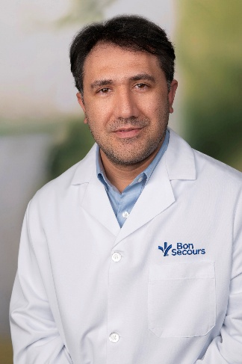 | Raihan Ghairatmal, MD  PGY 1  Medical School: Kabul Medical University of Curative Medicine  Personal Interests: I enjoy reading, gardening, and staying active through fitness activities.  Why SFFM-Blackstone: “I am particularly interested in St. Francis Medical Center-Blackstone because of its strong reputation for providing a supportive, resident-centered learning environment and its commitment to both clinical excellence and compassionate care. One of the aspects that stands out to me is the program’s emphasis on collaborative and interdisciplinary education, which I believe is essential for developing well-rounded physicians. The opportunity to train in a setting that values teamwork and inclusivity is very important to me. Additionally, I appreciate the program’s strong connection to the community and focus on health equity, as I am passionate about serving diverse patient populations and addressing healthcare disparities.”
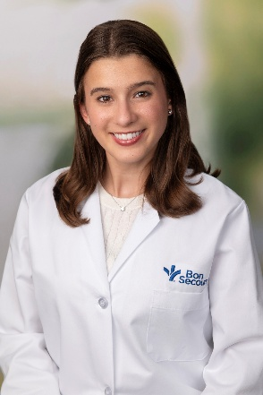 | Hannah Granger, MD  PGY 1  Medical School: Jacobs School of Medicine and Biomedical Sciences at the University of Buffalo  Personal Interests: My husband and I enjoy hiking in the mountains, exploring fun new bike trails in Richmond, and spending time with friends by the river. I also play the concert harp! In my spare time I enjoy trying new cake recipes, reading a good book, and watching Gilmore Girls!  Why SFFM: “What drew me to this program is its strong training in prenatal care and outpatient pediatrics. I have an interest in practicing full spectrum primary care and this program provides the range of experiences required to do this; from the unopposed OB experience to electives that allow me to engage with the community and resources available to patients to combat social barriers.”
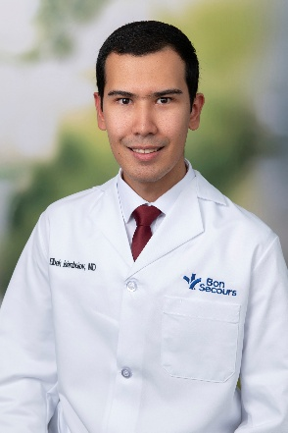 | Elbek Islambekov, MD  PGY 1  Medical School: Tashkent Medical Academy  Personal Interests: Outside of medicine, I enjoy spending time with my family, traveling, hiking, swimming, snowboarding, and cooking traditional Central Asian dishes, especially plov.  Why SFFM-Blackstone: “I chose Blackstone because I value caring for rural communities and improving access to healthcare. I look forward to building meaningful relationships with my patients and becoming part of the Blackstone community."
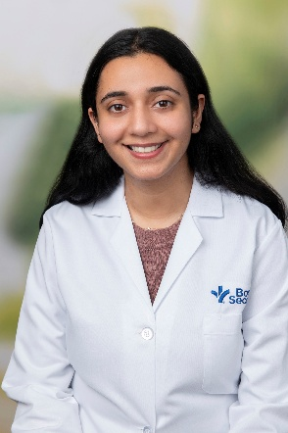 | Savneet Kaur, MD  PGY 1  Medical School: Himalayan Institute of Medical Sciences  Personal Interests: Traveling, being outdoors, chess, Trying out new things.  Why SFFM: “The program is unopposed and offers a broad clinical exposure. The Seniors and Attendings are very approachable and patient. They consistently check in on us. Also Richmond is a beautiful place with so much to do.”
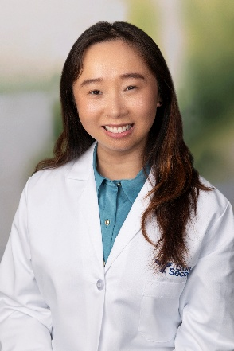 | Gloria Ma, MD  PGY 1  Medical School: Rutgers New Jersey Medical School  Personal Interests: My personal interests include hiking, running, crochet, and creative writing.  Why SFFM: “I have always wanted to get training in full-spectrum family medicine and the overall community at SFFM seemed very inviting.”
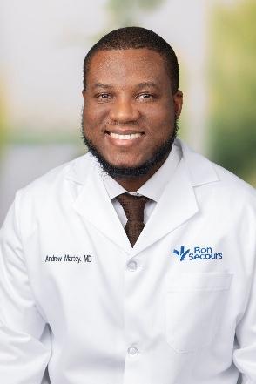 | Andrew Martey, MD  PGY 1  Medical School: University of Ghana School of Medicine and Dentistry  Personal Interest: My interests include Listening to Classical music, going to the cinema, long distance driving, reading novels, playing video games.  Why SFFM: “Chose SFFM because of the strong sports medicine curriculum and in-house fellowship, diverse and friendly resident/staff population, and location in beautiful Virginia.”
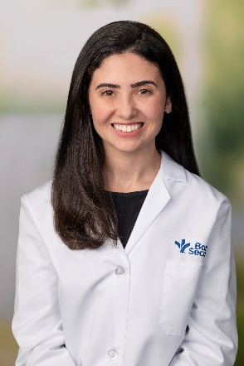 | Ana Carolina Reddo, MD  PGY 1  Medical School: Universiade Federal do Rio de Janeiro  Personal Interests: I enjoy trying new restaurants, cooking, cheering on Brazilian soccer and spending time with my husband!  Why SFFM: “During the interview process, I could tell right away how welcoming this program was. SFFM had everything I was looking for: great faculty, a true full-spectrum family medicine curriculum, a diverse patient population and real opportunities for international experience.”
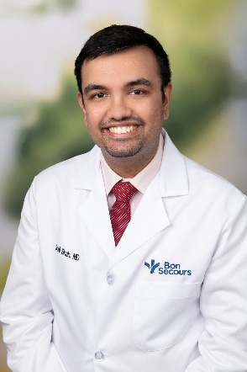 | Sahil Shah, MD  PGY 1  Medical School: Maulana Azad Medical College  Personal Interests: I've always loved performing on stage since my theater days. I enjoy swimming, juggling, cooking for my friends, singing, hiking and exploring new cities.  Why SFFM: “SFFM allows me to experience everything that family medicine has to offer, with the freedom to figure out and pursue what I really enjoy within it. Everyone here has been super supportive - I honestly felt at home from the get-go. Plus, the beautiful Virginia landscapes and the buzzy Richmond life are a huge bonus!”
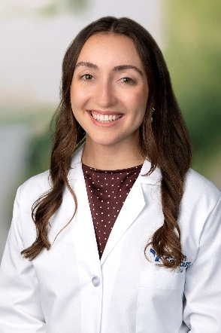 | Haley Whitfield, MD  PGY 1  Medical School: University of South Carolina School of Medicine  Personal Interests: Browsing antique malls & thrift stores, joining my husband on Facebook marketplace deals, boating, camping, skiing then après skiing, and hosting dinner dirties on the back porch.  Why SFFM: “Our program offers unopposed, full spectrum training for the resident who wants to be confident and competent to do anything family medicine could offer after graduation. I loved the smaller suburban hospital setting where our residency has close relationships with clinicians across the system and residents are often one on one with attendings. After doing an away rotation, I already felt right at home. It was an added bonus that my husband is from Virginia, and we now have family and friends a short drive away.”

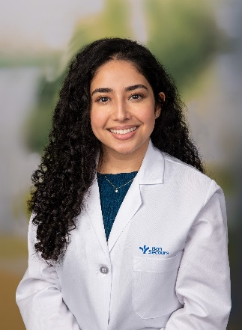 | Schabnam Ahmadi, MD  PGY 2  Medical School: Virginia Commonwealth University  Personal interests: Reality TV, tennis, hiking, yoga, spending time outdoors, admiring my cat while she naps  Why SFFM? “I want to be the most well-rounded and well-prepared physician to my patients, and I felt that SFFM's full spectrum, unopposed program would prepare me best for that. I was drawn to the strong experiences in women's health, pediatrics training, and global health opportunities. Richmond has also become home to me and getting to enjoy this city's food scene and nature is a plus!”
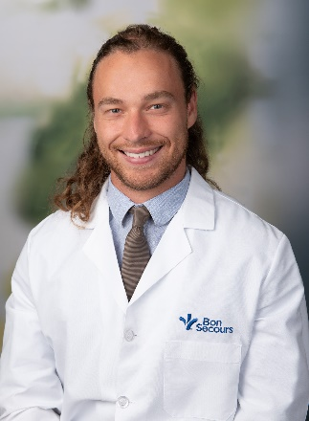 |  | Carter Fisher, DO  PGY 2  Medical School: Liberty University  Personal interests: “I love fishing, mushroom hunting, birdwatching, any sport (except basketball), spearfishing, shark tooth hunting, flower collecting, playing music, painting, and chilling with my buds”  Why SFFM-Blackstone? “During my interview, I was taken aback by how genuinely loving all the residents/staff members were. I knew that residency would be difficult, but I figured if I felt at home with the people, I would be happy. And I was right.”

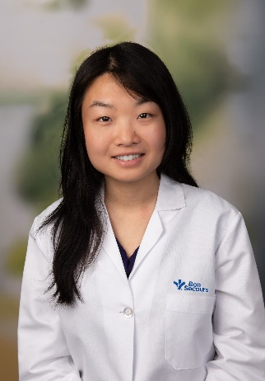
  Nina Weng, MD
  PGY 2
  Medical School: University of Virginia
  Personal interests: Reading, spending time in nature, hosting game/dinner nights, playing instruments, jamming to music on long drives, window shopping, visiting museums, horror movies/games, learning from my talented fiancé to cook food from all cultures!
  Why SFFM? “The physicians I looked up to during medical school recommended SFFM, and my interview with SFFM was my first and favorite. I connected with everyone I met and appreciate how this program encourages both professional and personal growth!”

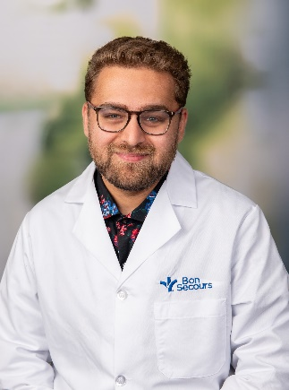 | Bilal Haque, MD  PGY 2  Medical School: Virginia Commonwealth University  Personal interests: horror movies, reading (Fantasy, Horror, Sci-Fi), trying new restaurants, taking my kids to the park  Why SFFM? “ Having attended VCU for Medical School, my wife and I fell in love with the Richmond area. There is always something to do, great food scene, and great parks. Having done my AI at SFFM during M4 year, I was able to see firsthand the autonomy given to the residents with really supportive attendings.”

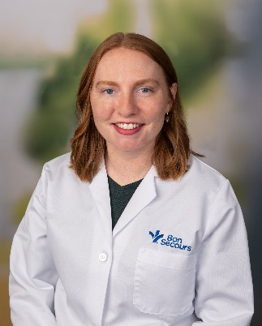 | Jennifer Holler O’Brien, MD  PGY 2  Medical School: University of Maryland School of Medicine  Personal interests: In my free time I enjoy reading, knitting, and exploring nature with my husband and my dog. I love all aspects of medicine, but I am particularly interested in women’s health and obstetrics.  Why SFFM? “ I chose to train at SFFM because they care for a large population of perinatal patients, which aligns with my goal of providing excellent women’s healthcare to my community."

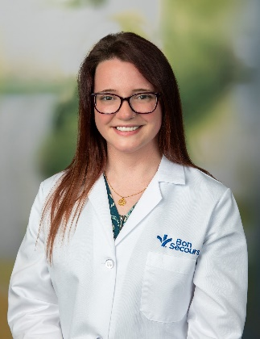 | Michelle Santiago, DO  PGY 2  Medical School: Edward Via College of Osteopathic Medicine – Virginia Campus  Personal interests: Spending time with my family and friends, my dogs, collecting houseplants, gardening, crocheting, reading fantasy novels, building houses in the Sims 4  Why SFFM? “I chose SFFM because it is an unopposed program that offers broad primary care experiences, especially in obstetrics and women’s health, which I’m really passionate about. What truly made it feel like the right fit, though, was how welcoming and supportive everyone was—from the all the current residents to the faculty and staff. It felt like a place where I could learn and grow both personally and professionally."

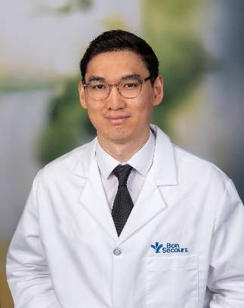 | Rauan Satbekov, MD  PGY 2  Medical School: Nazarbayev University School of Medicine  Personal interests: Outside of medicine, I love spending time outdoors whether it’s hiking, fishing, biking, or playing volleyball and Midlothian has been a great place for all of that. I’m also a big movie fan and always up for a good conversation about films or directors I’ve been into lately. And lastly, I’m a proud cat owner.  Why SFFM-Blackstone: “I chose SFFM-Blackstone because it felt like the right place to grow into the kind of doctor I want to be. I was looking for a program that offers strong, full-spectrum training while allowing me to serve a community that truly needs care. I want to work somewhere I can make a real difference and build long-term relationships with my patients.

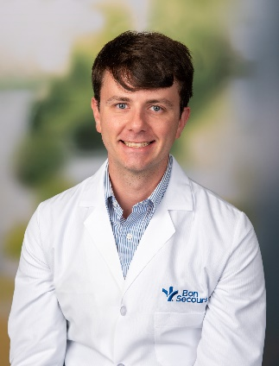 | Andrew Todd, MD  PGY 2  Medical School: West Virginia University School of Medicine  Personal interests: Rowing, Hiking, Dungeons and Dragons, and generally trying to teach myself (to varying levels of success) new skills (currently working on guitar, baking)  Why SFFM-Blackstone? “ I have family in the Richmond area, which initially led me to discover this amazing program. The more I learned about SFFM, the more I felt it was the right fit. Not just for the full-spectrum training, but because of the incredible support from the residents, faculty, nurses, and all the other staff members. It truly embodied the idea that it takes a village to raise a resident (especially an intern), and even in just my first few weeks here, that support has already been clear time and time again.”

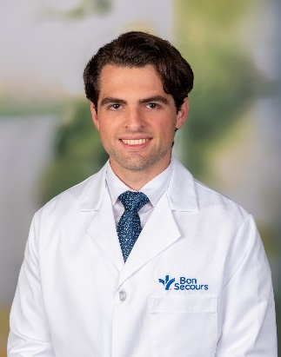 | Garrison Wright, MD  PGY 2  Medical School: University of Virginia  Personal interests: My personal interests outside medicine are literature and classical music.  Why SFFM? “I chose SFFM for the excellent full-spectrum training, which will prepare me to take care of patients anywhere in the country or the world.”

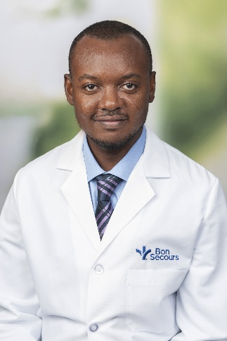 | Daniel Yebo, MD  PGY 2  Medical School: University of Ghana School of Medicine and Dentistry  Personal interests: I am passionate about people, and family medicine’s holistic approach allows me to grow as both a physician and a person. Outside medicine, I enjoy soccer, running, and spending time with my family.  Why SFFM? “The supportive faculty, co-residents, and staff at SFFM have been overwhelmingly welcoming and have created the ideal environment for my growth and training. So far St Francis Family Medicine has been more than a family, and of course, the free unlimited food at St. Francis Medical Centre is a wonderful bonus!”

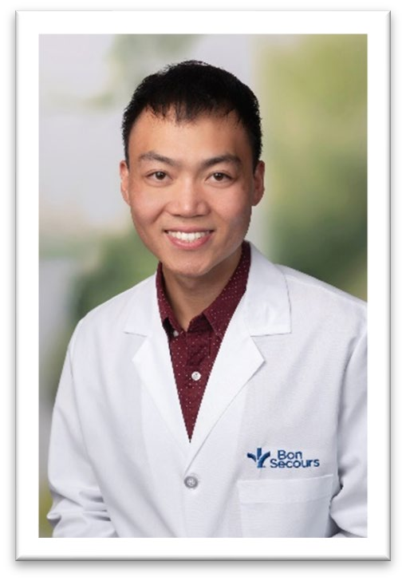
Ezra Chow, MD

PGY 3
Medical School: University of Tennessee Health Center

Personal interests: Running, Cooking, Pickle Ball, Traveling, Nutrition
Why SFFM? “Richmond unexpectedly waltzed into my life, like a jazz tune playing in the background. A barista’s casual mention led me to visit, and there, amidst the faculty, residents, and staff, I felt it—an undeniable sense of peace.
I moved to Richmond this June leaving family and friends behind in Knoxville and Memphis, Tennessee. The Richmond community welcomed me with open arms, and I am so happy to be here. I am excited to become a part of my patient's stories, and to contribute to the health and wellness of the city I now call home.”

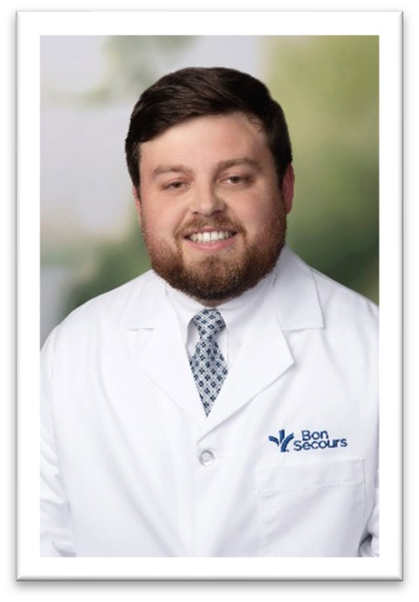
Christopher Ciccone, DO

PGY 3

Medical School: Edward Via College of Osteopathic Medicine, Virginia
Personal interests: Watching soccer and college football (Go Hokies!), playing sports (soccer, golf, disc golf), exploring local trails/parks, cooking

Why SFFM-Blackstone? “I chose SFFM because of all the great people I met during my interview!
I pursued the Blackstone track because I am interested in full scope rural medicine and so getting firsthand rural experience while also still getting the benefits of living/working in a community like Midlothian was the best of both worlds.”

Philip Grotz, MD
PGY 3

Medical School: University of Virginia
Personal interests: cooking, exploring nature, playing the piano, Latin / swing dancing

Why SFFM? “I chose SFFM because I wanted a chance to train at a well-established unopposed program not far from home, but more importantly, the people here are extraordinary.”
Taylor Fox, MD
PGY 3

Medical School: Virginia Commonwealth University
Personal interests: Walking with my 2 golden retrievers, restoring mid-century furniture, home renovations.

Why SFFM? “I love the program and am from the area, so I was fortunate enough to shadow and do 2 rotations here as a student, we have great faculty and a diverse patient population.”
Grace Le, MD
PGY 3
Medical School: Virginia Commonwealth University

Personal interests: baking, cooking, running, pickleball, volunteering with local ministries, hosting board game and dinner nights with my husband.

Why SFFM? “I chose SFFM because of the strong, full spectrum FM curriculum and the dedication to serving underserved communities here in my favorite city of Richmond and abroad on missions. I love the opportunities to explore personal interests in FM, like lifestyle and obesity medicine. I felt supported and welcomed by the faculty and residents so I knew it would be a great place to become the
physician I hope to be!”
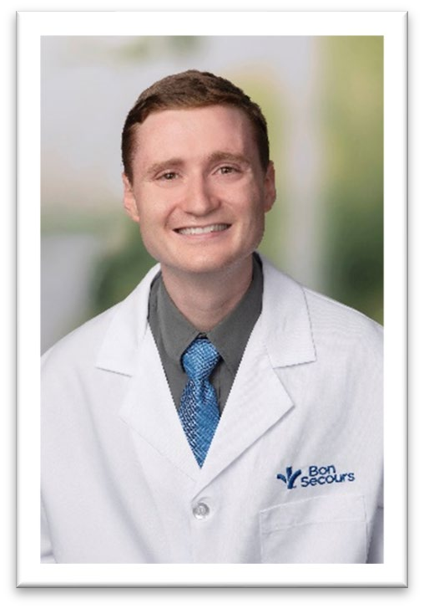
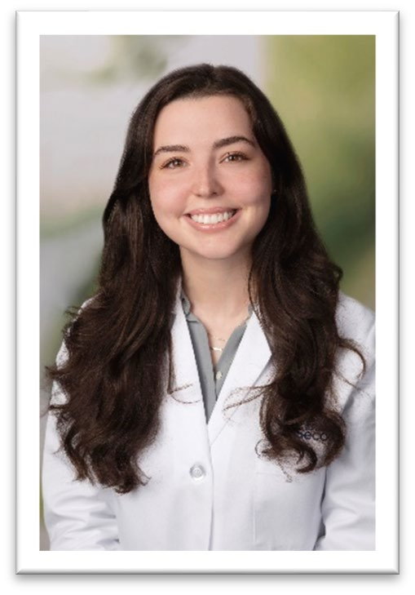
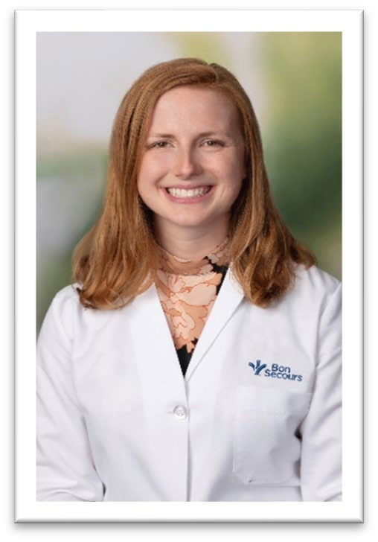

Ally Ledwith, MD
PGY 3
Medical School: Virginia Commonwealth University

Personal interests: Running, hiking, baking/cooking

Why SFFM? “I wanted a residency program where I could really do full-spectrum family medicine-pediatrics, hospital medicine, labor and delivery, outpatient, etc. I didn't just want exposure to these areas-I want to graduate feeling very competent, and I felt that SFFM would provide me with excellent opportunities. I am also from Richmond, VA, and I like the area, so I'm glad to be staying close by!”
Maddy Lee, MD
PGY 3

Medical School: Virginia Commonwealth University
Personal interests: Yoga, meditation, anything outdoors like hiking, camping, backpacking, kayaking, baking gf goodies, podcasts, watching The Office, church activities

Why SFFM-Blackstone: “I chose St. Francis- Blackstone because of its full spectrum, unopposed family medicine program in rural and suburban area with additional opportunities to learn in-patient medicine, women's health, obstetrics, sports medicine and procedures. I have also been so impressed by the
kindness and humanity of everyone in the program and administration.”
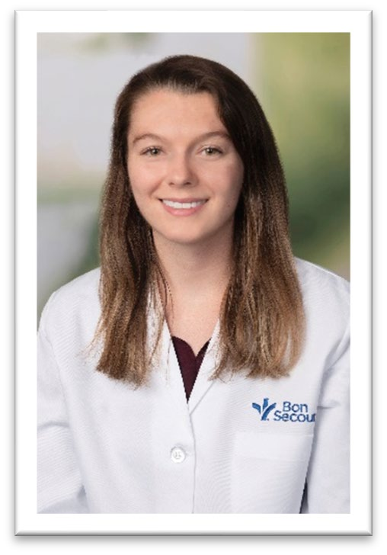
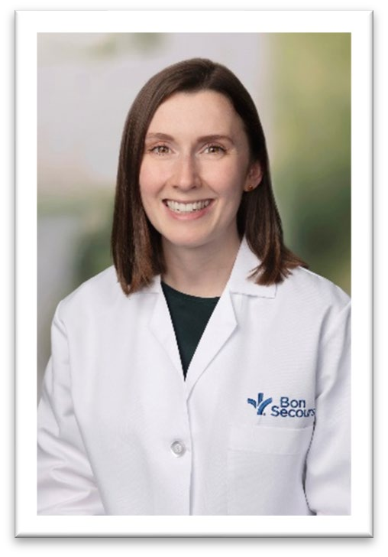

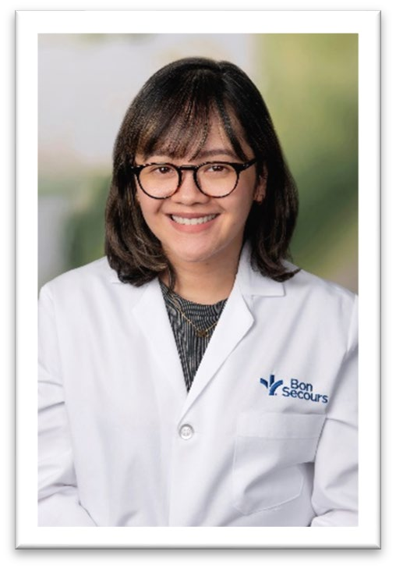
Michaela San Juan, MD

PGY 3

Medical School: University of the East Ramon Magsaysay Memorial Medical Center
Personal interests: Lego building, decorating, baking, travelling, trying out "new to us" restaurants, going to theme parks, Drag Race, spending time with my husband and my family whenever we're geographically together!

Why SFFM-Blackstone? “I chose St. Francis - Blackstone because the program offers opportunities that align with my professional interest and goal of being a well-rounded, compassionate clinician equipped to serve in any setting, whether locally or internationally.”

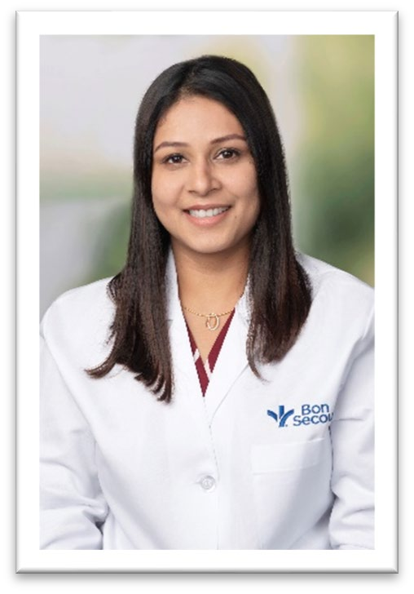
Neola Satish, MD

PGY 3
Medical School: Christian Medical College

Personal interests: I love to travel, dance, and spend time with friends and family.

Why SFFM? “I chose SFFM for the wonderful people who strive to provide a well-rounded training for their residents with emphasis on kindness and compassion.”

Courtney Silver, DO
PGY 3

Medical School: Arizona College of Osteopathic Medicine
Personal interests: I enjoy baking, traveling, exploring the Richmond area, and spending time with my family and two dogs.

Why SFFM? “I chose SFFM after the experience I had during my interview, everyone was so welcoming and kind, and I wanted to be a part of a residency program with a supportive community of residents, faculty, and staff. I also appreciated the unopposed, broad spectrum training this program provides.”
Nima Trivedi, DO
PGY 3

Medical School: Lake Erie Osteopathic Medical School, PA
Personal interests: I enjoy spending time with family, trying out new recipes, gardening, painting, & creative writing.

Why SFFM? “I chose SFFM because of the opportunity to learn and practice full scope family medicine. I was so amazed by the strong sense of community between the residents and faculty, and the dedication to creating a collaborative and supportive learning environment.”
Jacob Whitley, MD
PGY 3
Medical School: Eastern Virginia Medical School

Personal interests: I enjoy running, reading science fiction, trying new restaurants, watching football, and spending time with my wife and our cat.

Why SFFM? “I chose SFFM because the residents and faculty I met were kind and welcoming. SFFM is a well-rounded, full spectrum family medicine training program and I know I will be well prepared when I graduate. I am originally from Virginia and staying
close to my family was also important to me.”
