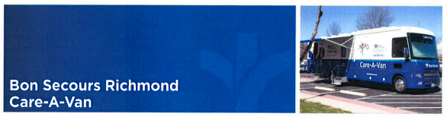

**What is the Care-A-Van?**

* A mobile health clinic serving Richmond for over 30 years.
* We treat patients who are **UNINSURED.**

**\*We do not accept Medicaid, Medicare, or Private Insurance\***

**What Services are Available?**

* FREE comprehensive primary care services for adults & children
* REDUCED-COST resource referrals.
* Wrap-around healthcare services
* Same-day services appointments
* Scheduled appointments for follow-up and routine care for established patients
* Immunizations and back-to-school physicals
* Behavioral health services
* Women’s health services
* Community health & outreach worker teams to address socioeconomic needs.
* Interpreter services available in over 150 languages

**For all other questions, please call the Care-A-Van main phone line: (804) 545-1920.**

**Please leave a message and we will return your call Monday through Friday within 24-48 hours.**

**If at any point you are experiencing a medical emergency, please call 911.**

**What Should I Know Before I Visit?**

* **All clinics operate by APPOINTMENT ONLY.**
* **Please call (804) 545-1923 between 7:00am and 8:30am Monday through Thursday to schedule an appointment.**
* Please arrive 15 minutes before your scheduled appointment time.
* Bring ALL medications and vaccine records with you to appointment.
* Minors must bring a parent or legal guardian. Parent or guardian must submit photo ID and/or proof of guardianship.

**What Are Other Costs?**

* Any healthcare services performed outside of the Care-A-Van
* Medication from the pharmacy
* Care-A-Van staff will help with connecting you to financial assistance programs.

**What Else Should I Know?**

* Take an active part in making decisions about your health care. We’ll support you and your family as you take steps to be your healthiest.
* As your medical home, we will help coordinate your care by storing your complete medical record history electronically.
* Let us know when you see other health care providers or have any tests so we can update your medical history. Providing your complete medical history enables us to provide better care.
* ****We have a dedicated team of medical providers on staff to provide evidence-based care and self-management.