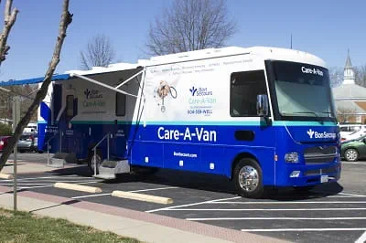
Bon Secours’ Care-A-Van at the Petersburg Center for Healthy Living
3335 South Crater Road | Suite 100 | Petersburg, VA 23803

Friday, October 2nd, 2026
Monday, October 12th, 2026
Friday, October 16th, 2026
Monday, October 26th, 2026
Call: (804) 964-8431
Read on the back for more information on how you can schedule an appointment. For direct access to the website use the QR code.



