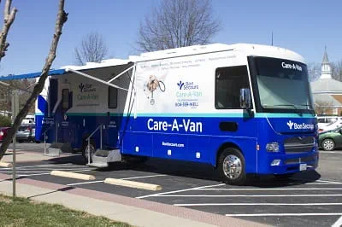
Bon Secours’ Care-A-Van at the Petersburg Center for Healthy Living

3335 South Crater Road | Suite 100 | Petersburg, VA 23803

Friday, May 1, 2026
Monday, May 11, 2026
Friday, May 15, 2026
Monday, May 11, 2026 (School Physical Appointments Only)

Call: (804) 964-8431
Read on the back for more information on how you can schedule an appointment.



