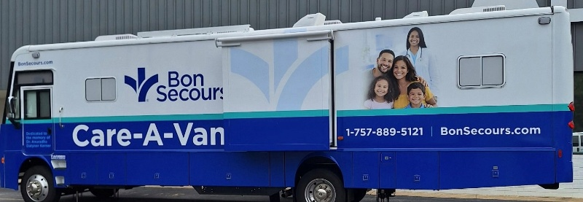
Important Facts for Patients

What is the Care-A-Van?

- A free mobile clinic serving the Hampton Roads area over 15 years.
- We provide primary care for uninsured adults and children
- Clinic sites are throughout Hampton Roads: Newport News, Hampton, Suffolk, Portsmouth, Chesapeake, Norfolk, and Virginia Beach.
- Schedule and general information can be found at https://www.bonsecours.com/locations/community-services/hampton-roads/care-a-van
Or by calling 757-889-5121.

What you can expect from us
- We will be your Primary Care Provider (PCP) and your “Medical Home”
- That means we will oversee all parts of your medical care, including visits to specialists and mental health providers, and make sure that all of your medical care fits into a plan that makes sense for you.
- We try to give you the tools and information you need to manage your own health. What you do at home makes a big difference.
- We have a dedicated team of medical providers on staff to provide evidence-based care and self-management.
- When you have a medical need that is beyond what we are able to offer, we will refer you to another health care provider and we will follow up with them to stay up to date on your latest plan of care.
- If you are referred for any services outside of the Care A Van, there may be a cost to those services. We will make every effort to find affordable options for you and to direct you to resources that offer financial assistance.
- If you contact us during work hours with questions or medical concerns, you will hear back from us within one business day for medical questions and 72 hours for medicine refills or non-medical concerns.
- If testing is done, we will give you your results within 2 weeks.

What are other costs?
- Any healthcare services performed outside of the Care-A-Van
- Medication from the pharmacy
- Care-A-Van staff will help with connecting you to financial assistance programs.

What else should I know for my visit?
- Walk-in clinics are first come, first served. We have a few locations that offer walk-ins; please check our clinic schedule. Otherwise, we encourage scheduling an appointment at any of our other clinic sites.
- Please bring all your medications and photo identification with you. If you do not have photo identification with you, we can still see you.
- Minors must bring a parent or legal guardian to their first visit. Parent or guardian must submit photo ID and/or proof of guardianship. For subsequent visits, a parent or guardian can give written permission during their first visit for someone else to bring the child to appointments if they choose to.

How can I contact the Care A Van?
- Medication Refill: Check with your pharmacy first; they can fax a refill request to us. We will let them know if you must return to the clinic for a visit or if the medication can be refilled.
- Telephone Calls: During or after office hours, call 757-889-5121. Because we are mobile, there is not always someone on this number, but please leave a message, and someone will call you back or address your concern. You can expect a reply within one business day for health-related questions, or 72 hours for medication refills or non-health-related concerns.
- MyChart- If you have internet access at home or a smartphone, please sign up for MyChart, which is a way to communicate with us electronically. Your access code for your personal and private MyChart account is on the last page of the after-visit summary.

