Bon Secours St. Francis Medical Mobile Van September |  |  |  |  |  |  |  |  |  |  |  | 2025
Sunday | Monday | Tuesday |  |  | Wednesday |  |  | Thursday | Friday |  |  |  | Saturday
 | 1  HOLIDAY | 2  CALVARY BAPTIST  11 TAMPA Street  GREENVILLE, SC |  |  | 3  SPINX  1520 S. PLEASANTBURG DR  GREENVILLE, SC |  |  | 4  WATERS ON AUGUSTA APARTMENTS  100 SHEMWOOD LANE  GREENVILLE, SC | 5  SAN SEBASTIAN  2300 OLD BUMCOMBE  GREENVILLE, SC |  |  |  | 6
7 | 8  TRIUNE MERCY CENTER  222 RUTHERFORD ST  GREENVILLE SC | 9  REEDY RIVER BAPTIST  1012 MAULDIN ROAD  GREENVILLE SC |  |  | 10  SHADY OAK BAPTIST  1117 WHITE HORSE RD  GREENVILLE SC |  |  | 11  PROJECT HOST  525 ACADEMY ST  GREENVILLE SC | 12  SAN SEBASTIAN  2300 OLD BUMCOMBE  GREENVILLE SC |  |  |  | 13
14 | 15  TRIUNE MERCY CENTER  222 RUTHERFORD ST  GREENVILLE SC | 16  HISPANOS COMUNIDAD  1000 E. MAIN STREET  EASLEY SC |  |  | 17  PLEASANT VALLEY  510 OLD AUGUSTA  GREENVILLE SC |  |  | 18  TGHA  70 THURSTON Street  GREENVILLE SC | 19  STERLING COMMUNITY  113 MINUS STREET  GREENVILLE SC |  |  |  | 20
21 | 22  TRIUNE MERCY CENTER  222 RUTHERFORD ST  GREENVILLE SC | 23  FIRST CHRISTIAN FELLOWSHIP  110 MONTANA ST  GREENVILLE, SC |  |  | 24  THE CHURCH OF  WEST GANTT  1452 WHITE HORSE  GREENVILLE SC |  |  | 25  SPINX  1301 FAIRVIEW RD  SIMPSONVILLE SC | 26  GREENVILLE TECH  506 S. PLEASANTBURG DRIVE  GREENVILLE, SC |  |  |  | 27
28 | 29  TRIUNE MERCY CENTER  222 RUTHERFORD ST  GREENVILLE SC | 30  FRONT PORCH HOUSING  1433 CLEVELAND ST.  GREENVILLE SC
Inclement Weather  The Mobile Van follows the Greenville County School District inclement weather schedule and will not be operational if Greenville County Schools have early dismissal or if schools are closed. | Mobile Site Hours: 8:00AM-3:00PM unless a noted time adjustment  Mobile Cell Number:  (864) 436-4999  Please contact Lori Center for calendar questions or request at 864-605-3919

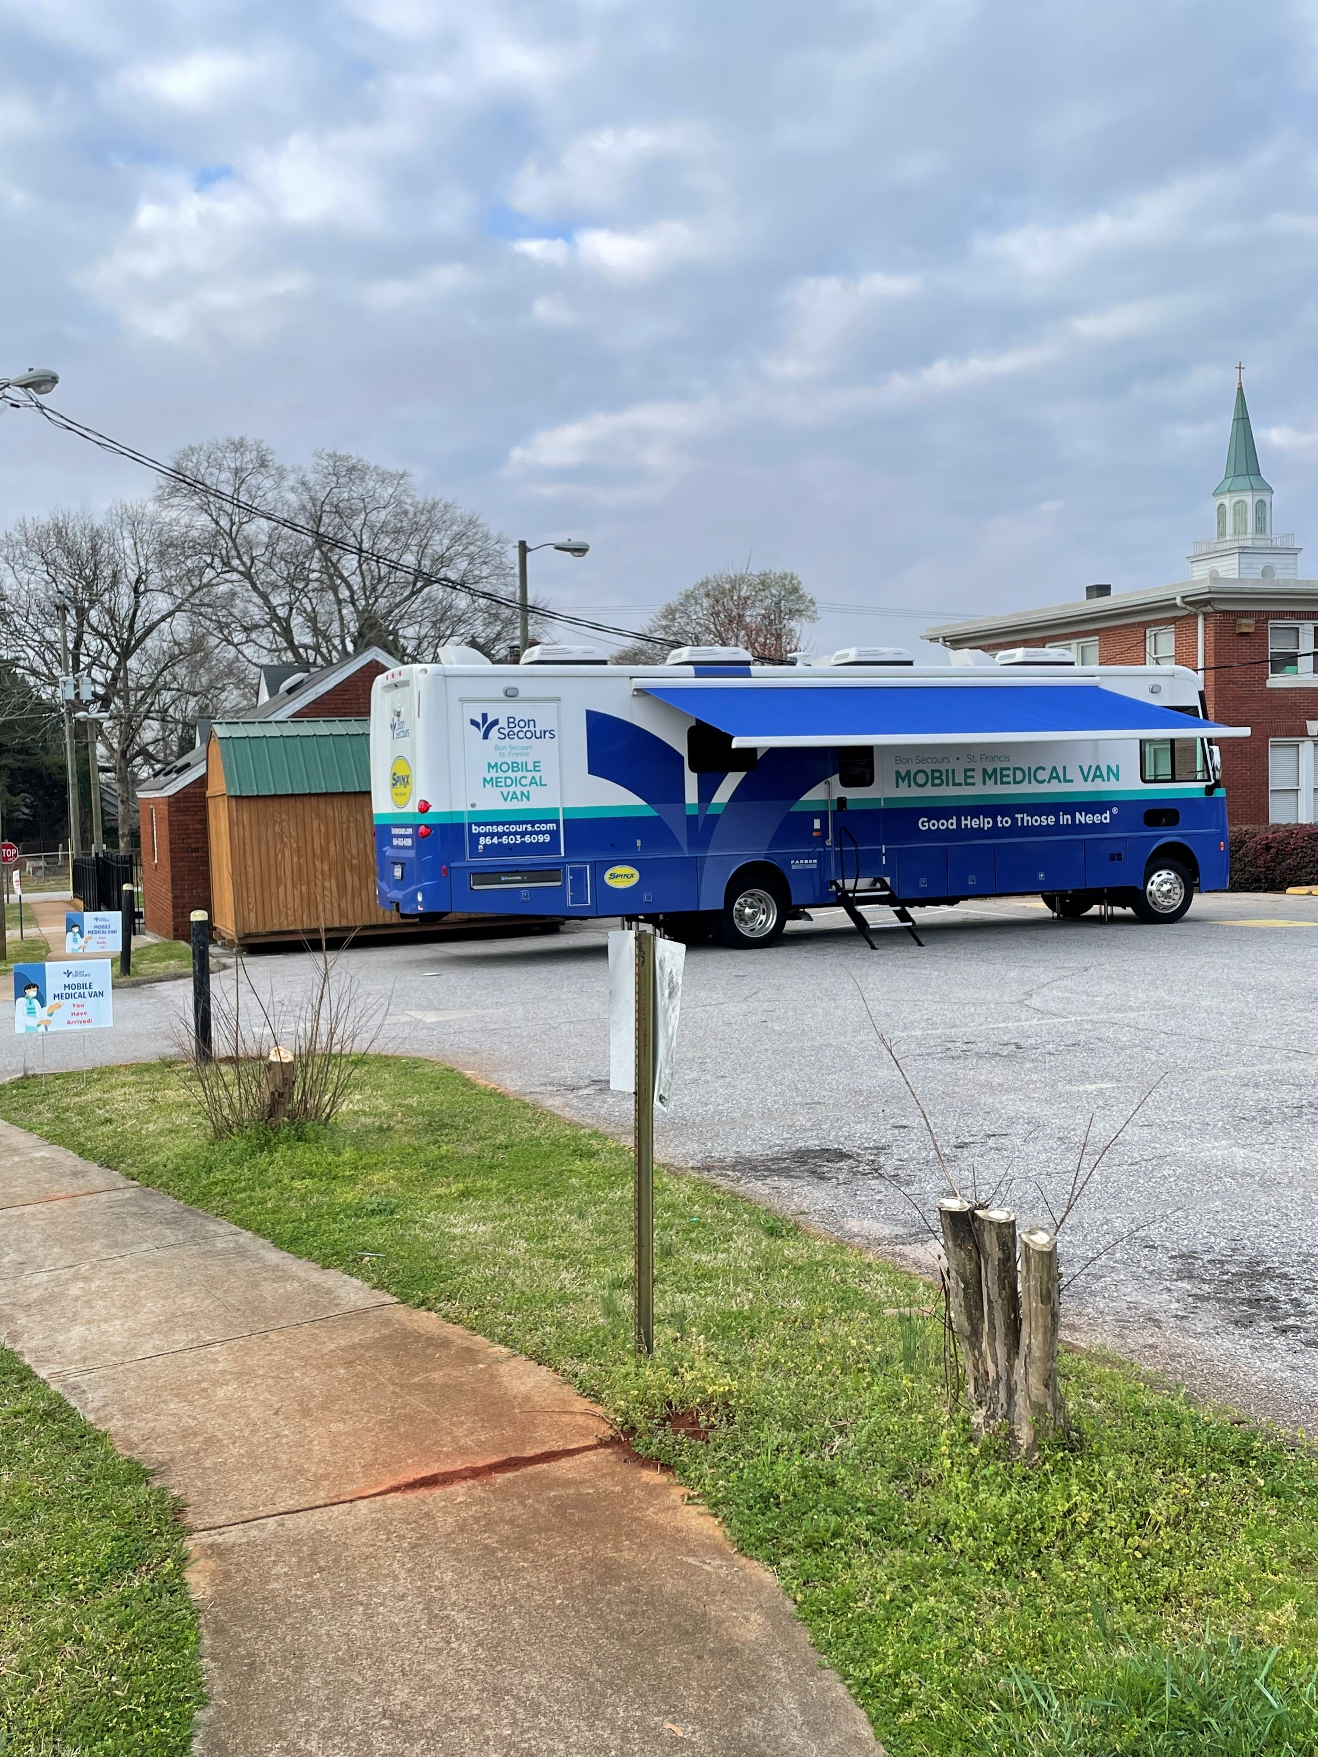 |  |  |  | Inclement Weather  The Mobile Van follows the Greenville County School District inclement weather schedule and will not be operational if Greenville County Schools have early dismissal or if schools are closed. |  |  | Mobile Site Hours: 8:00AM-3:00PM unless a noted time adjustment Mobile Cell Number:  (864) 436-4999 /Lunch Break at 12:00noon  Please contact Lori Center for calendar questions or requests at 864-605-3919

THE MOBILE TEAM

REMINDER REMINDER REMINDER REMINDER REMINDER

Bon Scours St. Francis Medical Mobile Unit Site Date: ___________________________

Location: ____________________________________

